Lesson 5 Demo 20: Troubleshooting Container Networking

This section will guide you to:

* Troubleshoot container networking in different ways

**Step 1:** Troubleshooting using debug commands like *logs* and *inspect*

* Create an ubuntu container

*sudo docker run -t -d --name container1 ubuntu:latest*

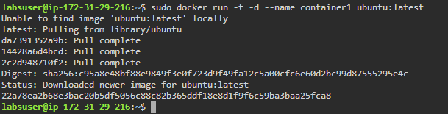

* List all the running containers

*sudo docker ps*

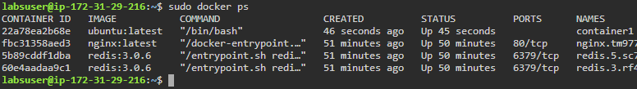

* Use the following command to inspect a container:

*sudo docker inspect container1*

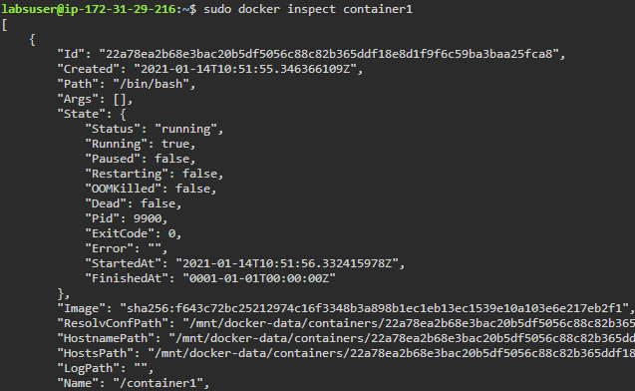

**Note:** You can additionally use these commands to troubleshoot a container networking:

*sudo docker container logs <container id/ name>*

*sudo docker network inspect -v <network id/name>*

*sudo docker node ls*

**Step 2:** Troubleshooting using network troubleshoot tools like *nicolaka* or *netshoot*

* Use *nicolaka* or *netshoot* tool for container debugging, as all Linux networking tools are packaged in this container

*sudo docker run -it --net container:container1 nicolaka/netshoot*

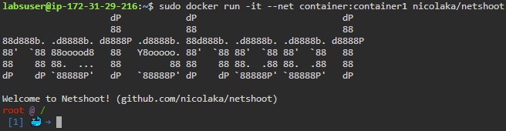

* Use the following command to troubleshoot host network:

*sudo docker run -it --net host nicolaka/netshoot*

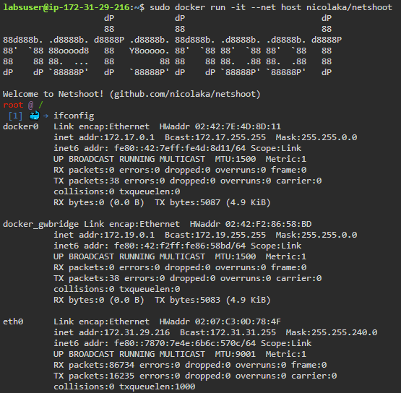

* Use *nsenter* to enter any namespace with *netshoot* running as a privileged container

*#running netshoot in privileged mode*

*docker run -it --rm -v /var/run/docker/netns:/var/run/docker/netns --privileged=true nicolaka/netshoot*

**Note:** The following commands can be used inside network namespace for troubleshooting:

*ifconfig #interface list*

*brctl show #bridge list*

*ip route show #route table*

*bridge fdb show #encapsulation detail*

*ipvsadm #load balancing*